**FULL ADDER:**

**EXP NO:23**

**AIM:**To design and implement the full adder using the Logisim simulator.

**APPARATUS:** logicism

**PROCEDURE:**

1)      Pick and place the necessary gates.  
2)      Insert 3 inputs into the canvas.   
3)      Connect the inputs to the XOR gate, AND gate, and OR gate.  
4)      Insert 2 outputs into the canvas.   
5)      Make the connections using the connecting wires.  
6)      Verify the truth table.

**TRUTH TABLE:**

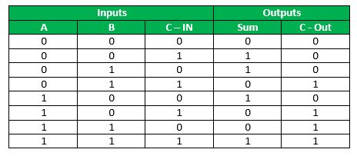

Sum=(A⊕B) ⊕Cin

Carry=A.B+ (A ⊕B)

**OUTPUT:**

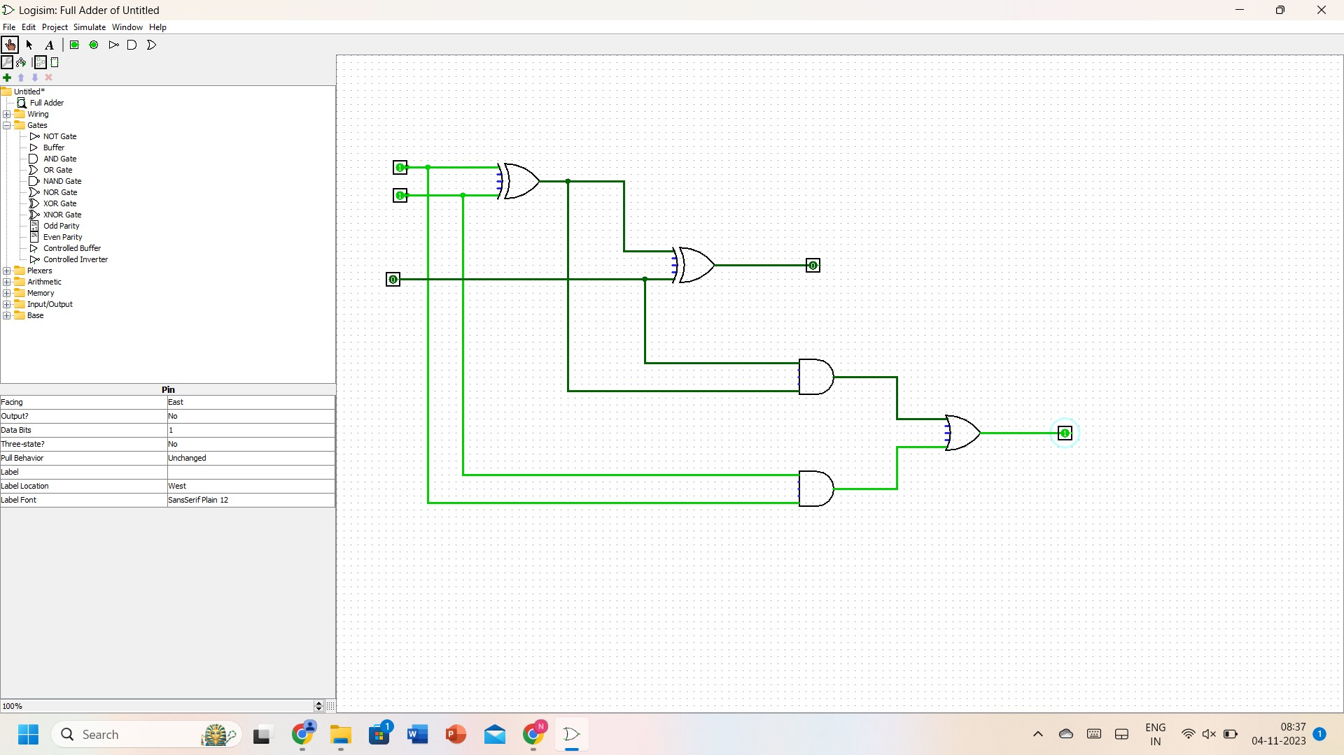

**RESULT:** Thus full adder has been designed and implemented successfully using a Logisim simulator.